[0001] TITLE OF INVENTION
LIPTRAC - Lipreading through a Temporal Recurrent and Convolutional Neural Network – Real time Visual Speech Recognition through using a Microprocessor System using a CRNN
[0002] INVENTOR:
Monish Saravana Kumar Divya Sundari

[0003] BACKGROUND OF THE INVENTION
Relevant Field
The present invention relates to the field of assistive communication technologies. More specifically, it pertains to systems and methods for visual speech recognition (VSR), commonly known as lipreading, using machine learning, particularly deep neural networks, to transcribe spoken language from visual-only input in real-time.
Description
Hearing loss affects a significant portion of the global population, presenting substantial communication challenges. While lipreading is a skill utilized by many individuals with hearing impairments, human proficiency in lipreading is inherently limited, with accuracy rates often below 30%, even for experienced lipreaders.
Traditional assistive technologies, such as hearing aids, aim to amplify sound. However, their effectiveness can be compromised in noisy environments, and they may not be suitable or affordable for all individuals, particularly those with profound hearing loss or conditions like aphonia (loss of voice) or aphasia (difficulty with speech). Furthermore, the cost of hearing aids can be a significant barrier to access.
In recent years, Visual Speech Recognition (VSR) has emerged as a promising technological solution. VSR systems aim to automatically transcribe speech by analyzing the lip movements of a speaker from video input. Early VSR systems often faced challenges with accuracy, robustness to different speakers, and varying environmental conditions (e.g., lighting, head pose).
More recent VSR models, often based on deep learning architectures like Convolutional Neural Networks (CNNs) and Recurrent Neural Networks (RNNs), have demonstrated improved accuracy. However, many state-of-the-art VSR models prioritize maximizing transcription accuracy (e.g., minimizing Word Error Rate (WER) or Character Error Rate (CER)) often at the expense of computational efficiency and processing speed. This results in high inference latency, making such models impractical for real-time applications where immediate transcription is crucial for fluid communication.
Additionally, many existing VSR models are trained on limited datasets or are speaker-dependent, limiting their generalizability and real-world applicability. The complexity of these models often necessitates powerful and expensive computational hardware, further hindering their deployment in accessible, low-cost, and portable devices.
Therefore, a need exists for a VSR system that not only achieves a practical level of accuracy but is also optimized for real-time performance, is robust to various speakers, and can be deployed on readily available, low-power hardware, thereby offering a more accessible and affordable communication tool.
[0004] SUMMARY OF INVENTION
The present invention, referred to as LIP-TRAC (Lipreading through a Temporal Recurrent and Convolutional Neural Network), provides a system and method for real-time visual speech recognition. LIP-TRAC is designed to address the limitations of prior art by offering a lightweight, efficient, and accurate VSR solution capable of transcribing speech from visual lip movements with low latency, suitable for practical communication and improving accessibility for individuals with hearing impairments or speech difficulties.
The LIP-TRAC system, in one embodiment, comprises several key stages:
- Video Input Acquisition: Capturing video frames of a speaker.
- Lip Region Detection and Preprocessing: Automatically detecting the speaker's face, isolating the mouth or lip region, converting the region to grayscale, and normalizing the frames to enhance relevant features and reduce computational load.
- Feature Extraction and Sequence Modeling: Utilizing a lightweight Convolutional Recurrent Neural Network (CRNN) architecture. This architecture typically includes:
  - Spatial Feature Extraction: 3D Convolutional Neural Network (3D CNN) layers to learn spatio-temporal features from sequences of lip images.
  - Temporal Modeling: Recurrent Neural Network (RNN) layers, specifically Gated Recurrent Unit (GRU) layers, to model the temporal dependencies and dynamics of lip movements over time.
  - Architecture:
    - 3D Convolution Layer
    - 3D Max Pooling Layer
    - 3D Convolution Layer
    - 3D Max Pooling Layer
    - 3D Convolution Layer
    - 3D Max Pooling Layer
    - Time Distributed Layer
    - Bidirectional Gated Recurrent Unit Layer
    - Dropout Layer
    - Bidirectional Gated Recurrent Unit Layer
    - Dropout Layer
    - Dense Layer
- Transcription Generation: Employing a Connectionist Temporal Classification (CTC) loss function during training, which allows the network to learn alignments between the visual input sequence and the corresponding text transcription without requiring frame-by-frame labeling. The trained model then outputs a sequence of characters or words representing the transcribed speech.
- Real-Time Deployment: The model is optimized for deployment on low-power, portable hardware, such as a Raspberry Pi single-board computer (Raspberry Pi 5), enabling its use in a wearable or easily accessible device.
The invention aims to provide a VSR tool that is more practical for everyday use than existing solutions, offering a significant improvement in accessibility and affordability for individuals requiring assistance in understanding spoken communication. The system's architecture and training methodology are tailored to achieve low latency transcription, a critical factor for effective real-time interaction.

[0005] DRAWINGS / VISUALS
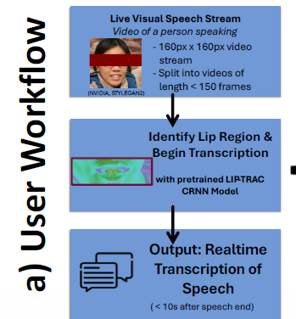
Figure 1. Showing user workflow of using LIPTRAC


Figure 2. Showing simulated real world usage, with potential integration of mobile app.
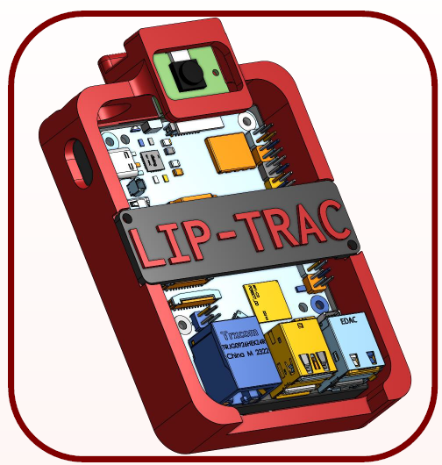
Figure 3. 3D Render of wearable device with integrated camera, and microprocessor (Raspberry Pi 5) to run the VSR Model.
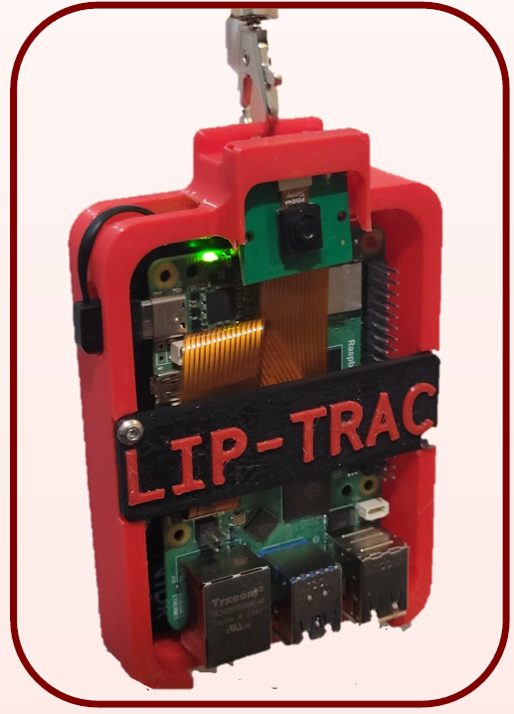
Figure 4. Physical, functional, wearable device, with 3D printed case, Raspberry Pi 5, Arducam, and 5000 mAh power bank.

[0006] DETAILED DESCRIPTION OF THE INVENTION

I. System Architecture and Components
A. Input Module:
The input module is responsible for acquiring visual data of a speaker. This typically involves a digital camera (e.g., a webcam, smartphone camera, or a camera integrated into a custom device) capable of capturing a video stream. The video is processed as a sequence of image frames.

B. Preprocessing Module:
This module prepares the raw video frames for input into the CRNN model. The steps involved are:

1. Frame Extraction: Individual frames are extracted from the input video stream.

2. Grayscale Conversion: Each frame is converted from color (e.g., RGB) to grayscale. This reduces computational complexity as only one color channel needs to be processed, and color information is generally not critical for lipreading.

3. Face Detection: A face detection algorithm, such as a Haar Cascade classifier (e.g., frontal face Haar Cascade), is used to locate the face of the speaker within each frame.

4. Lip Region Cropping: Once the face is detected, the mouth or lip region is isolated. This is typically done by defining a region of interest (ROI) relative to the detected facial landmarks or bounding box. For example, the lip region might be cropped to a standardized size, such as 40x120 pixels. This step is crucial for focusing the model's attention on the most informative part of the face for speech.

5. Normalization: The cropped lip region images undergo normalization to ensure consistency across different videos and lighting conditions. One method involves:

Calculating an "average frame" for a given video clip (or a moving window of frames).

Calculating the standard deviation of each frame from this "average frame."

Subtracting each frame from the original frame to obtain a "normalized frame" or performing temporal normalization by subtracting the mean pixel intensity over the temporal window. This helps to highlight dynamic changes in lip shape.

6. Down sampling/Resizing: The cropped lip region is resized to a fixed input dimension required by the CRNN model (e.g., 40x120 pixels), which also contributes to reducing data size (e.g., from an initial 160x160 pixel input).

C. Core VSR Engine (LIP-TRAC CRNN Model):
The core of LIP-TRAC is a lightweight Convolutional Recurrent Neural Network (CRNN).

1. 3D Convolutional Layers (Spatial-Temporal Feature Extractors):

The input to the CRNN is a sequence of preprocessed lip region frames (e.g., T x H x W x C, where T is sequence length, H is height, W is width, C is channels (1 for grayscale)).

A first 3D convolutional layer (e.g., 32 filters, kernel size 5x5x5, stride 1x2x2) followed by 3D Max Pooling (e.g., pool size 1x2x2).

A second 3D convolutional layer (e.g., 64 filters, kernel size 3x3x3, stride 1x1x1) followed by 3D Max Pooling (e.g., pool size 1x2x2).

A third 3D convolutional layer (e.g., 96 filters, kernel size 3x3x3, stride 1x1x1) followed by 3D Max Pooling (e.g., pool size 1x2x2).

These layers learn hierarchical features from the lip movements, capturing both spatial patterns within each frame and short-term temporal patterns across consecutive frames. A kernel size such as 5x5x5 is chosen to capture sufficient features while balancing computational load, especially when GRUs are used later.

2. Time Distributed Layer:

The output of the 3D CNN stack is typically reshaped or passed through a Time Distributed layer wrapping a 2D CNN or a Flatten layer. This prepares the features for the recurrent layers by applying the same operation to each temporal slice of the feature maps.

3. Recurrent Layers (Temporal Modeling):

One or more Bidirectional Gated Recurrent Unit (GRU) layers are used. For instance, two Bidirectional GRU layers (e.g., each with 256 units).

GRUs are chosen over LSTMs (Long Short-Term Memory units) for their comparable performance in many sequence modeling tasks but with fewer parameters and gates (2 gates in GRU vs. 3 in LSTM), leading to faster computation and reduced risk of overfitting, which is advantageous for real-time applications.

Bidirectional GRUs process the sequence in both forward and backward directions, allowing the model to capture context from past and future frames.

4. Dropout Layers:

Dropout layers are interspersed (e.g., after GRU layers) during training to prevent overfitting by randomly deactivating a fraction of neurons.

5. Dense Layer (Output Layer):

A final dense (fully connected) layer with a softmax activation function is used. The number of units in this layer corresponds to the size of the character set (e.g., alphabet characters 'a'-'z', space, plus a "blank" token for CTC).

D. Training Process:

Dataset: The model is trained on a large-scale dataset of videos with corresponding transcriptions, such as the LRS2 (Lip Reading Sentences 2) dataset from BBC television, which provides diversity in speakers, head poses, and lighting.

Loss Function: The Connectionist Temporal Classification (CTC) loss function is employed. CTC is suitable for sequence-to-sequence tasks where the alignment between input and output sequences is variable and not known in advance. It allows the model to learn to transcribe speech without requiring explicit segmentation of words or phonemes in the video.

Optimizer and Learning Rate: An optimizer such as Adam is used. A learning rate scheduler (e.g., exponential decay, or starting with a small learning rate like 3.0 x 10^-6 and adjusting) is utilized to decrease the learning rate over time, aiding convergence and preventing overshooting the optimal minima.

Batch Size: Training is performed using mini-batches of video sequences.

E. Output Module:
The output module takes the predictions from the CRNN model (typically a probability distribution over characters for each time step) and decodes them into a readable text transcription. A greedy decoding or beam search decoding algorithm can be used with the CTC output.

II. Wearable Device

As shown in figures 3 & 4.

Housing: A compact, lightweight housing, potentially 3D printed, designed to be worn (e.g., clipped to clothing, worn as a pendant).

Camera: A small, embedded camera module (Arducam if using Raspberry Pi’s)

Processing Unit: A low-power single-board computer, such as a Raspberry Pi 5, capable of running the LIP-TRAC model. The model would be optimized (e.g., quantized) for efficient inference on such hardware.

Power Source: A rechargeable battery, at least 2500 mAh

Output: This could be a small integrated display, or the device could transmit the transcribed text wirelessly (e.g., via Bluetooth) to a paired smartphone or other display device.

III. Operation

A user speaks in front of a camera connected to the LIP-TRAC system.

The system captures the video stream and processes it frame by frame.

The preprocessing module detects the lip region, crops it, converts it to grayscale, and normalizes it.

The sequence of processed lip frames is fed into the trained LIP-TRAC CRNN model.

The transcribed text is displayed to the user or another recipient in real-time or near real-time (e.g., within a few seconds of speech completion).

Process occurs as shown in figure 1 & figure 2.

